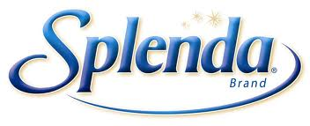

We all use it. We want our lattes, coffees and baked goods to taste a little sweeter...without the calories. The little, yellow packet we recognize as Splenda claims to be a "No Calorie Sweetener." But is it really zero calories?

Splenda has roughly four calories per packet. The U.S. Food and Drug Administration (FDA) allows the legal labeling of "zero calories" on any food source containing less than five calories per serving.

But what exactly is Splenda? Splenda contains sucralose, dextrose and maltodextrin. Sucralose, a carbohydrate, isn't metabolized by the body. So dextrose and maltodextrin are the calorie culprits. Dextrose is an additive that provides texture to food and serves as a thickening agent. Maltodextrin functions as a filler. Essentially, they're carbohydrates added to give texture.

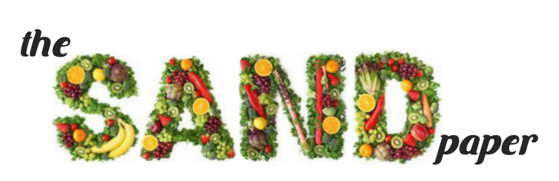

Sources:

<http://www.splenda.com/faq/no-calorie-sweetener>

<http://www.wisegeek.org/what-is-maltodextrin.htm#didyouknowout>

So when you alter a food

recipe to make it healthier by exchanging one cup of actual sugar with one cup of Splenda, you save calories, but you still consume 96 calories. Many sugar-free coffee creamers contain 15 calories in a 1 tbsp serving size, equivalent to about four packets of Splenda.

Therefore, the little, yellow packet is not what it claims. With each packet you pour, multiply that by four.

Splenda's sweetening agent is sucralose, which has no calories. So to clarify the claim, Splenda *contains* a "No Calorie Sweetener." But the underlying truth is that the product itself is not a "No Calorie Sweetener." If you're looking for a sweetening condiment with few calories then Splenda is a good alternative.