SAND Sports Nutrition Workshop: Field Hockey
Mixed Greens Salad

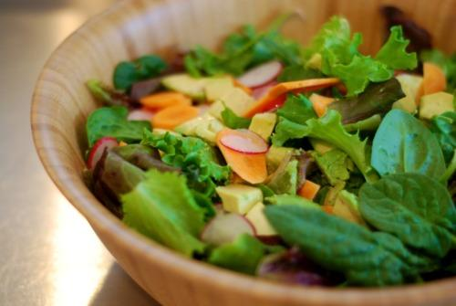
Team 3 - Mixed Greens Salad

Ingredients - 6 servings
6 cups Romaine lettuce
10 cherry tomatoes, halved
6 tbsp craisins
2 tbsp slivered almonds
Dressing

Directions:
- Wash lettuce. Break up lettuce in small pieces and place in bowl.
- Slice cherry tomatoes in half.
- Place cherries, craisins and almonds in bowl.
- Pour dressing and mix thoroughly.

