SAND Sports Nutrition Workshop: Field Hockey
Fruit Kabobs

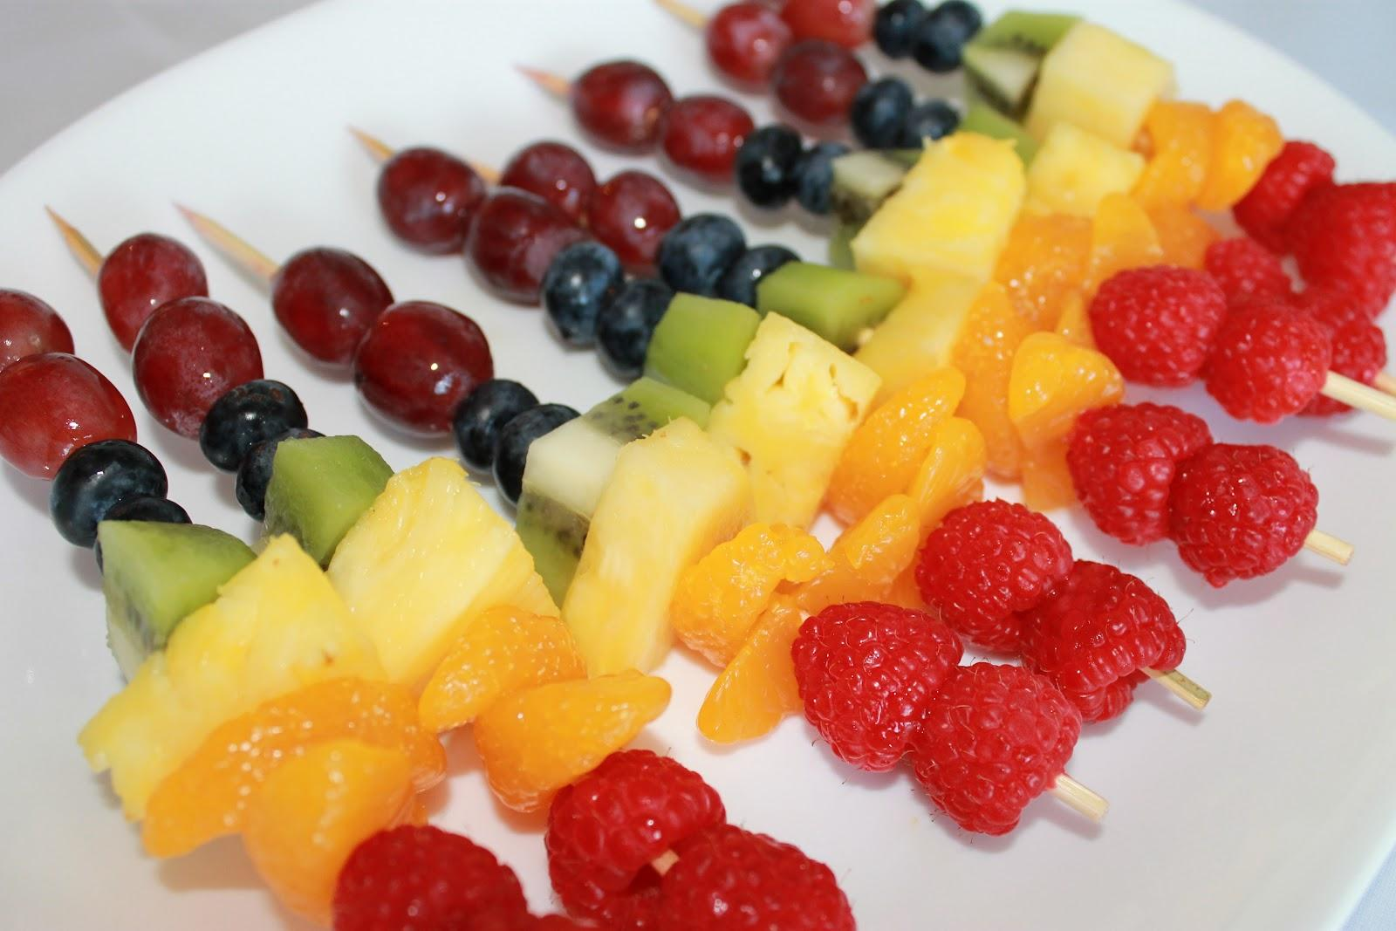
Team 3 - Fruit Kabobs

Ingredients - 1 skewer
4 grapes
2 pineapple slices
3 strawberry slices
2 banana slices

Directions:
- Slice strawberries into quarters.
- Slice bananas.
- Place a grape on the end of the skewer followed by slices of pineapple, strawberries, bananas and finish with a grape.

