Post Workout Foods

That feeling that you get after a killer workout? The one where you feel like you could take on the world….Well that can go away in the blink of eye if you do not properly nourish your body. Your body needs to restore energy and repair your overused muscles to help them grow. Below are some great post-workout snacks filled with vital nutrients that your body craves after leaving the gym!

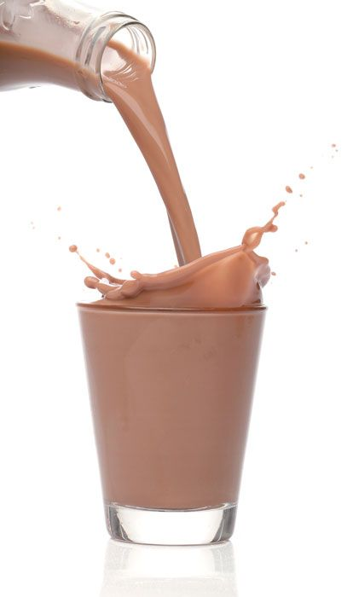
Chocolate Milk: A simple glass of this favorite helps rebuild your tired muscles with protein, and refuel your energy with carbs.
Smoothie with protein powder: Choose your favorite fruits and add to it a scoop of protein powder. There are endless smoothie recipes on the web, which is great so that you don’t get bored.
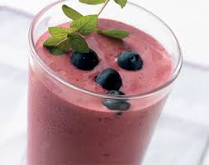

Greek Yogurt: Loaded with protein, this snack can be extremely satisfying and fill you up. Try adding granola or fresh fruit, to add some flavor!
Frozen Nutty Banana Bites: My personal favorite, these are the perfect bite sized snack and have everything your body needs to recover after that tough workout. Cut a ripe banana into small slices, put a dab of peanut butter in between, and make a peanut butter banana sandwich. Freeze for 1 hour, and these delicious snacks are ready to go!
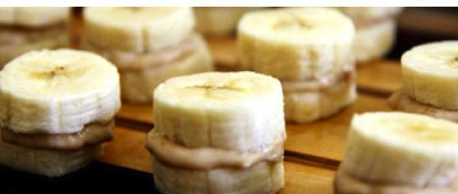

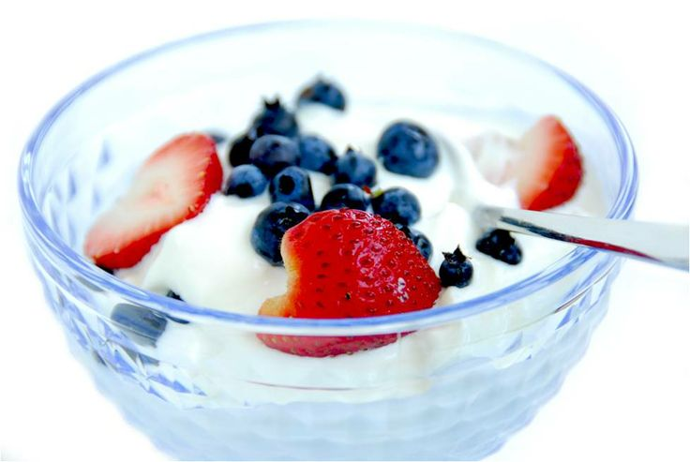

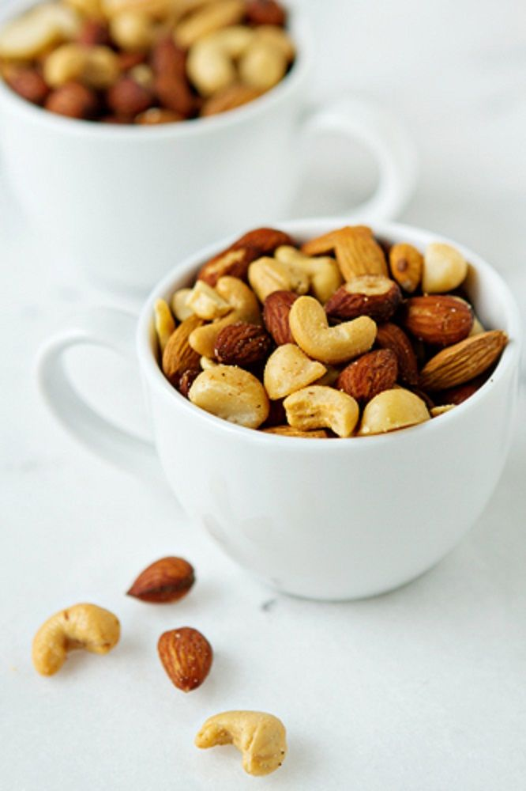
Nuts: Nuts are rich in the good fats that are healthy for your heart. Additionally there are a great way to incorporate nutrients such as iron, vitamin E and protein into your diet.

