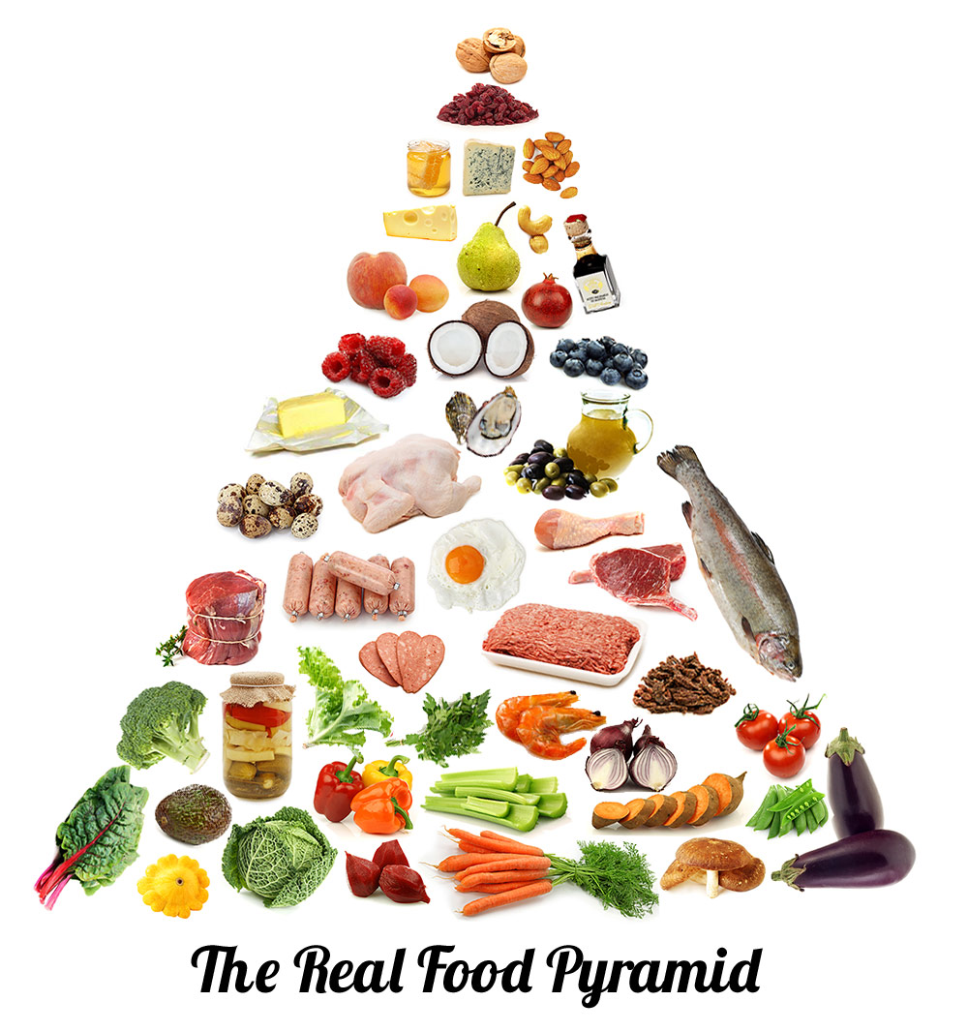
What is the Paleo diet?
The Paleo Diet
Are you an endurance athlete interested in the Paleo diet? Here is a quick go-to guide for all your Paleo-related questions!

The Paleolithic diet, more commonly known as the Paleo diet, is sweeping the nation with the idea of “eating like a caveman.” The Paleo diet focuses on eating natural foods found only in the Paleolithic area. This leads to avoiding: processed foods, refined sugars, potatoes, dairy, etc.

Can I follow the Paleo diet if I am an athlete?
It is feasible for endurance athletes to follow the Paleo diet as long as adjustments are made. The Paleo diet is an extreme diet to follow, especially for athletes. Make sure you start Paleo at a low-stress time in your life. It will not be beneficial to start the diet right before a big event or a very stressful time. Your body will need time to adjust!
What to look for…
As an athlete, you will need to pay close attention to what you are eating in order to obtain optimal performance. Here are a few tips:
- During the base of the season: focus on obtaining 50% of calories from carbohydrates, 30% from fats and 20% from protein
- During the peak of the season: focus on obtaining 60% of your calories from carbohydrates, 20% from fats and 20% from proteins

Before, During and After Exercise
Stage I: Before a workout, it is recommended to eat low glycemic index carbohydrates with a small amount of protein and fat about two hours before the workout. Eat an additional 200-300 calories every hour until the workout begins.
Example: Cup of melon, hard boiled egg
Stage II: During the workout, it is necessary to consume high glycemic index carbohydrates, which is easiest in the form of fluids.
Example: Sports drinks are highly recommended for this
Stage III: 30 minutes after the workout, try and have a recovery drink with a carbohydrate to protein ratio of 4-5:1.
Example: 16 ounces of fruit juice with a banana, about 3 tablespoons of protein powder and a few pinches of salt
Stage IV: For continued recovery, continue to consume foods with a carbohydrate to protein ratio of 4-5:1.
Example: Salmon with asparagus and a leafy green salad

Pros/Cons
The Paleo diet is an extreme diet change to make. Switching to this diet may cause frustration due to lack of performance because your body will need time to adjust. Despite this, the Paleo diet is high in nutrients, lowers body acidity and can lead to muscle protein synthesis.

